1. **Various commands**;
2. ‘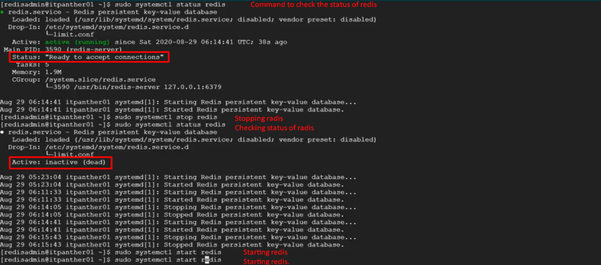
3. **To shutdown redis server**: First way.
4. **To shutdown redis server**: 2nd Way  
   
5. 